FOREX DAILY - REPORT
Tuesday 5th April 2016
Currencies – AUD, CAD, CHF, EUR, GBP, JPY, NZD, SGD, USD,

There were 1 entry, 0 TP1 exits, 0 TP2 exits, 0 TP3 exits and 2 Stop exits and 0 close at markets in Forex Daily.

There are 4 new orders for today.

Please check into this Forex Position size calculator – we believe it is 1 of the best available - http://www.myfxbook.com/forex-calculators/position-size

Entries: EURJPY Sell Stop 126.94

Exits: EURJPY Buy Stop 126.547, EURJPY Buy Stop 126.547

Take Profit Reached:

The colour coding we are currently using is as follows:

Amended orders or stops
Retained Orders or stops – no change
New working orders
Immediate action required
Short Sell
Change Contract Specifications

POSITIONS:

PAIR: OLD ACTION NEW TP1 TP2 TP3

Close Positions

Amended

Stop Positions

CADJPY Sell Stop 86.98 Amend 86.208 87.09
EURGBP Buy Stop 0.7893 Amend 0.7906 0.8046 0.8116
USDJPY Sell Stop 113.493 Amend 112.307 111.03 109.93

Limit Positions

Retained

Stop Positions

EURCAD Buy Stop 1.4749 Retain 1.4749 1.5003
EURCHF Buy Stop 1.0882 Retain 1.0882 1.1024
EURJPY Sell Stop 127.57 Retain 127.57 125.18
GBPCAD Buy Stop 1.8632 Retain 1.8632 1.9215
GBPJPY Sell Stop 162.07 Retain 162.07 157.77
GBPUSD Sell Stop 1.4460 Retain 1.4460 1.3947
USDCAD Buy Stop 1.2960 Retain 1.2960 1.3402
USDCHF Sell Stop 0.9735 Retain 0.9735 0.9476

Limit Positions

WORKING ORDERS:

CANCELLED ORDERS:

AUDUSD Buy Stop 0.7701

Name Direction Entry Stop Loss TP1 TP2 TP3 Trade Risk

Amended

Stop Orders

Limit Orders

Retained

Stop Orders

GBPAUD Buy Stop 1.8778 1.8718 1.9817 60 pips

Limit Orders

NEW ORDERS:

Name Order Type Entry S. L. TP1 TP2 TP3 Trade Risk

Stop Orders

AUDNZD Sell Stop 1.1065 1.1120 1.0877 55 pips
GBPAUD Buy Stop 1.8782 1.8718 1.9218 64 pips
USDJPY Buy Stop 112.41 110.97 113.42 114.42 144 pips
XAUUSD Sell Stop 1214 1223 1187 90 pips

Limit Orders

CHARTS:

Stop Orders

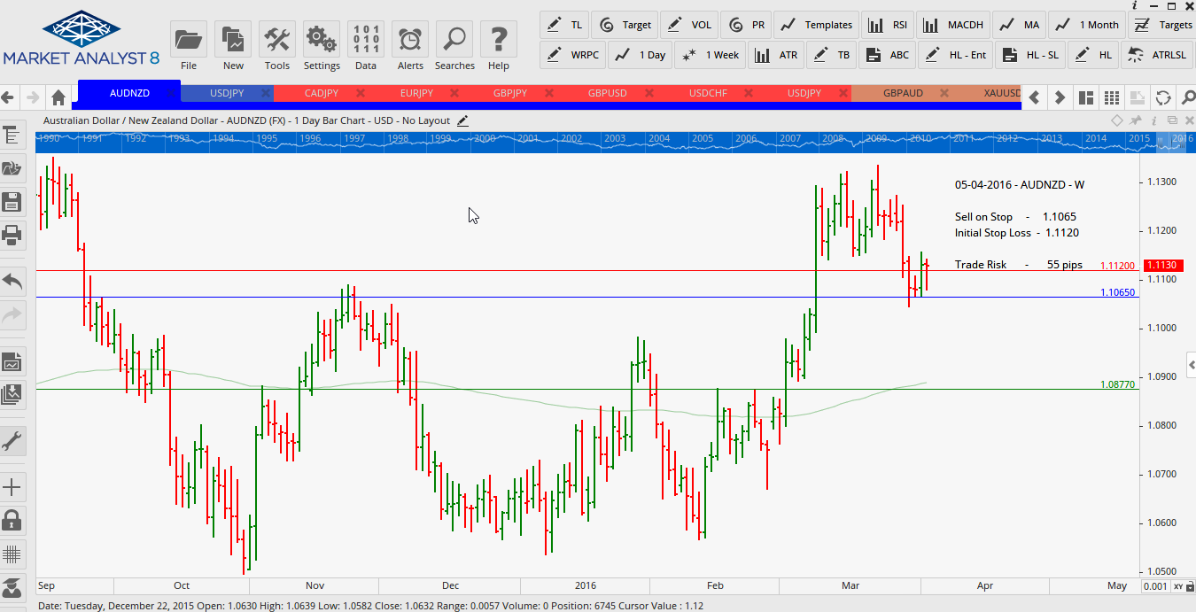

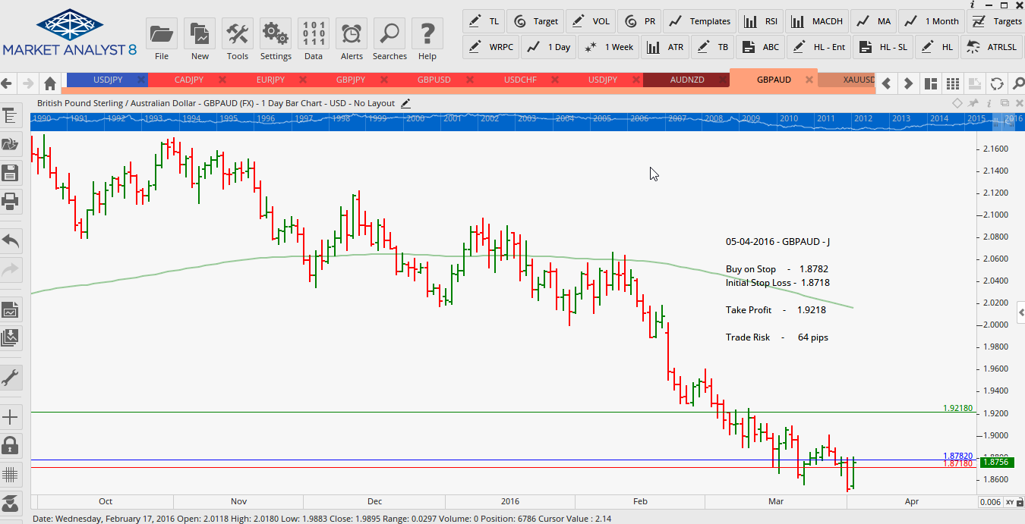

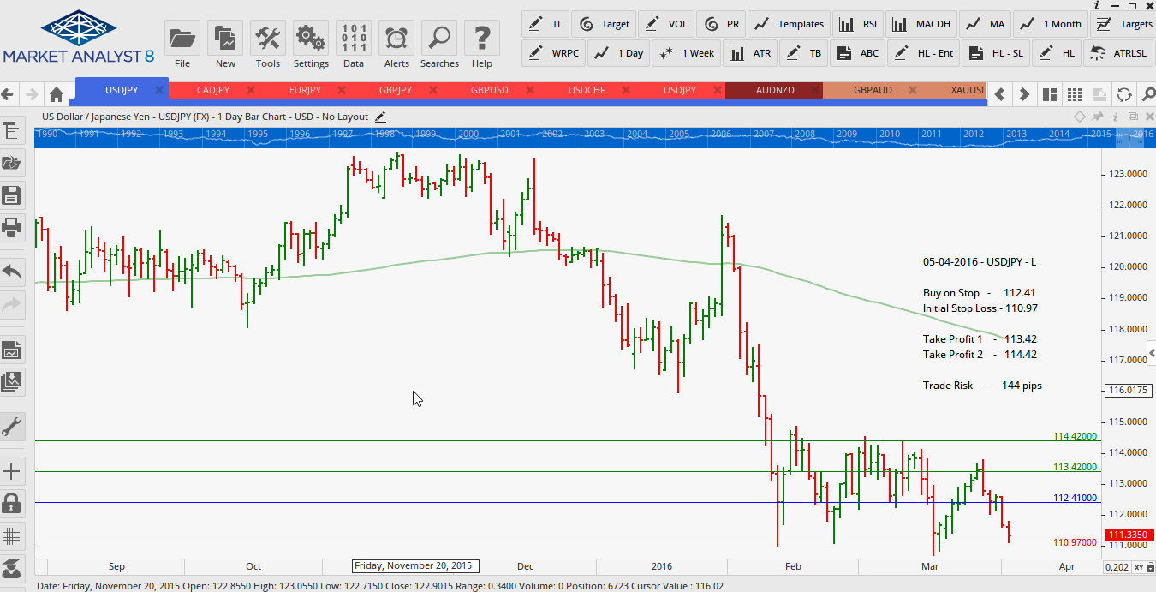

Limit Orders

