DAILY FOREX
Thursday 28th January 2016

Currencies – AUD, CAD, CHF, EUR, GBP, JPY, NZD, SGD, USD,

There were 3 entries, TP1 exits, TP2 exits, TP3 exits and 2 Stop exits and 2 close at markets in Forex Daily.

There are new orders in Forex Daily.

Entries: AUSUSD Buy Stop, AUDUSD Buy Limit, EURJPY Buy Stop

Exits: AUSUSD Buy Stop, AUDUSD Buy Limit, NZDUSD Sell Stop, USDCHF Buy Stop

Take Profit Reached:

The colour coding we are currently using is as follows:

Amended orders or stops
Retained Orders or stops – no change
New working orders
Immediate action required
Short Sell
Change Contract Specifications

OPEN POSITIONS:

PAIR: OLD ACTION NEW T P 1 TP 2 TP 3

Close Positions

Amended

Stop Positions

CADJPY Buy Stop 81.990 Amend 82.324 86.382
EURJPY Buy Stop 127.815 Amend 127.966 132.82
USDCAD Sell Stop 1.4329 Amend 1.4305 1.40026

Limit Positions

Retained

Stop Positions

AUDCCAD Sell Stop 0.9971 Retain 0.9971 0.9706
AUDSGD Buy Stop 0.9838 Retain 0.9871 1.0277
EURCAD Sell Stop 1.5888 Retain 1.5653 1.5080
EURGBP Sell Stop 0.7756 Retain 0.7703 0.7437
GBPCHF Buy Stop 1.4120 Retain 1.4227 1.4837

Limit Positions

WORKING ORDERS:

CANCELLED ORDERS:

EURJPY Buy Limit 126.000, EURUSD Sell Limit 1.1120, GBPAUD Sell Limit 2.095, GBPJPY Buy Stop 170.27

With multiple take profit orders - Close half the position at the "Take Profit 1"and then move the stop to the entry value, close the balance of the position at the "Take Profit 2"

Name Direction Entry Stop Loss TP 1 TP 2 TP3 Trade Risk

Amended

Stop Orders

Limit Orders

Retained

Stop Orders

Limit Orders

EURCAD Buy Limit 1.5200 1.5120 1.5500 80 pips
EURUSD Sell Limit 1.1010 1.1110 1.0610 100 pips
GBPCHF Buy Limit 1.4060 1.3960 1.4760 100 pips
GBPCHF Sell Limit 1.4800 1.4880 1.4100 80 pips
USDCAD Buy Limit 1.4000 1.3920 1.4200 80 pips

NEW ORDERS:

With multiple take profit orders - Place an on Stop Order for half the position with the entry & Stop Loss and Take Profit at the "Take Profit 1". Place a 2nd order for half the position as before but Take Profit at the "Take Profit 2" target. Once the 1st target has been reached move the stop to the entry value.

Name Order Type Entry S.L. TP 1 TP 2 TP 3 Trade Risk

Stop Orders

GBPJPY Sell Stop 168.53 169.11 166.57 58 pips
NZDJPY Sell Stop 76.02 76.59 74.09 57 pips

Limit Orders

CHARTS:

Stop Orders

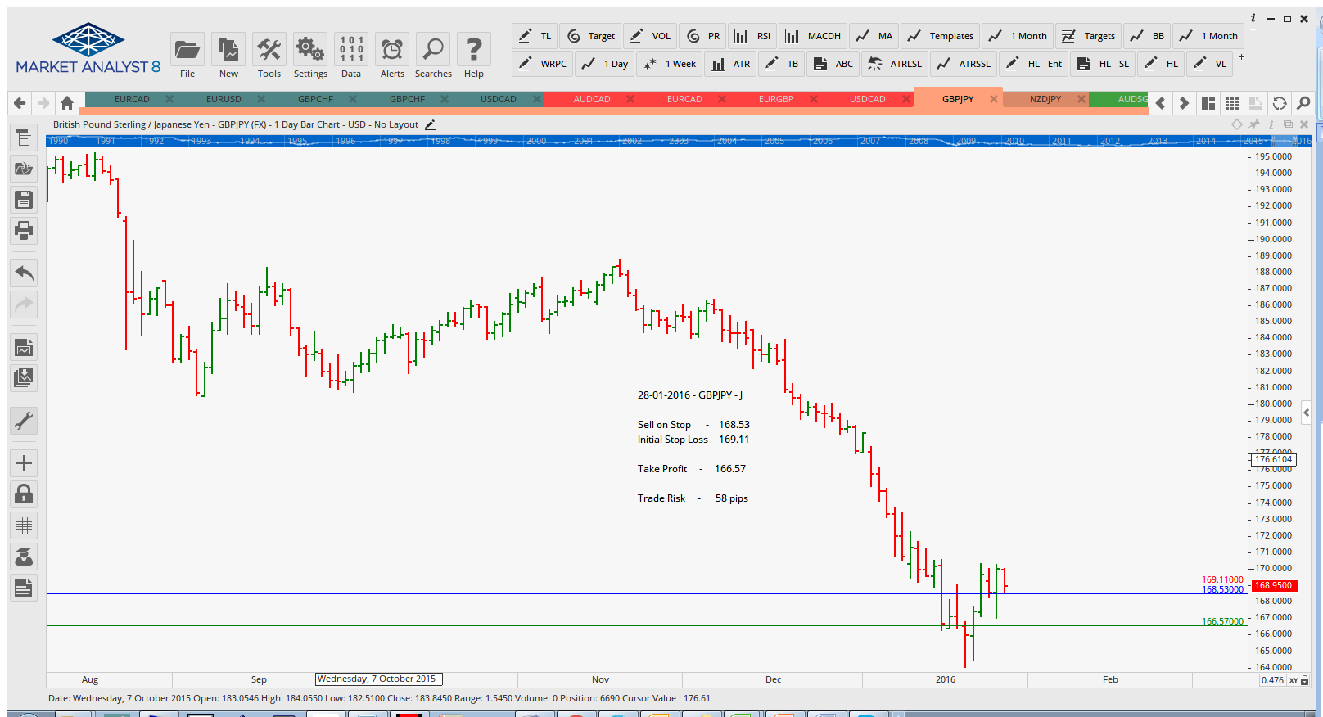

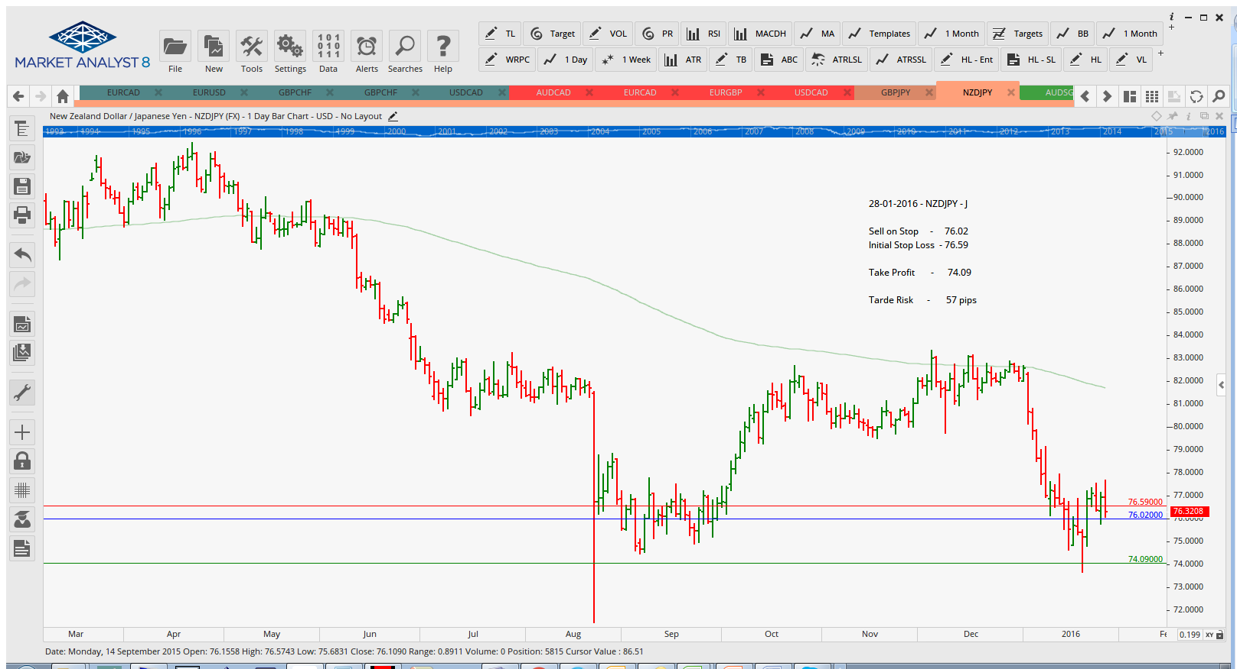

Limit Orders

