FOREX DAILY - REPORT
Thursday 21st April 2016
Currencies – AUD, CAD, CHF, EUR, GBP, JPY, NZD, SGD, USD,

There were 1 entry, TP1 exits, 0 TP2 exits, TP3 exits and 1 Stop exits and 0 close at markets in Forex Daily.

There are 4 new orders for today.

Please check into this Forex Position size calculator – we believe it is 1 of the best available - http://www.myfxbook.com/forex-calculators/position-size

We recommend that Forex orders for Mondays, not be placed until 4 hours after opening – around 02:00 GMT – this is because of the volatility which often happens around that opening

Entries: USDJPY Buy Stop 109.88

Exits: GBPCAD Buy Stop 1.8170

Take Profit Reached:

The colour coding we are currently using is as follows:

Amended orders or stops
Retained Orders or stops – no change
New working orders
Immediate action required
Short Sell
Change Contract Specifications

POSITIONS:

PAIR: OLD ACTION NEW TP1 TP2 TP3

Close Positions

Amended

Stop Positions

EURGBP Sell Stop 0.7953 Amend 0.7948 0.7692
EURGBP Sell Stop 0.7 Amend 0.7948 0.7650
GBPUSD Buy Stop 1.4205 Amend 1.4314 1.4428 1.4522
GBPUSD Buy Stop 1.4205 Amend 1.4314 1.4452 1.4587

Limit Positions

Retained

Stop Positions

AUDCAD Sell Stop 0.9947 Retain 0.9947 0.9710
EURJPY Buy Stop 122.715 Retain 122.715 126.64
USDJPY Buy Stop 108.82 Retain 108.82 113.81

Limit Positions

WORKING ORDERS:

CANCELLED ORDERS:

EURGBP Buy Stop 0.8027

Name Direction Entry Stop Loss TP1 TP2 TP3 Trade Risk

Amended

Stop Orders

Limit Orders

Retained

Stop Orders

GBPAUD Buy Stop 1.8488 1.8270 1.9700 218 pips

Limit Orders

NEW ORDERS:

Name Order Type Entry S. L. TP1 TP2 TP3 Trade Risk

Stop Orders

EURUSD Buy Stop 1.1408 1.1261 1.1489 1.1570 147 pips
EURUSD Sell Stop 1.1281 1.1337 1.1055 55 pips
USDJPY Sell Stop 107.71 109.97 106.77 105.83 226 pips
USDJPY Buy Stop 110.32 109.00 113.325 132 pips

Limit Orders

CHARTS:

Stop Orders

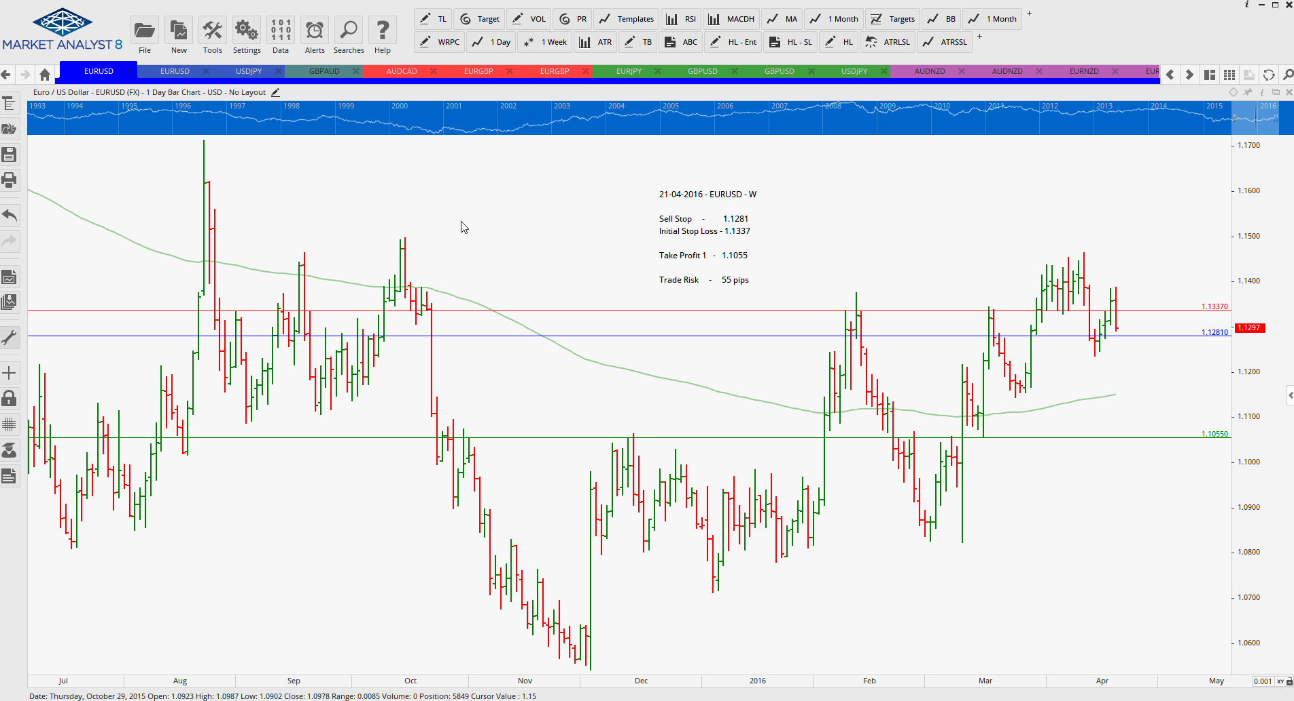

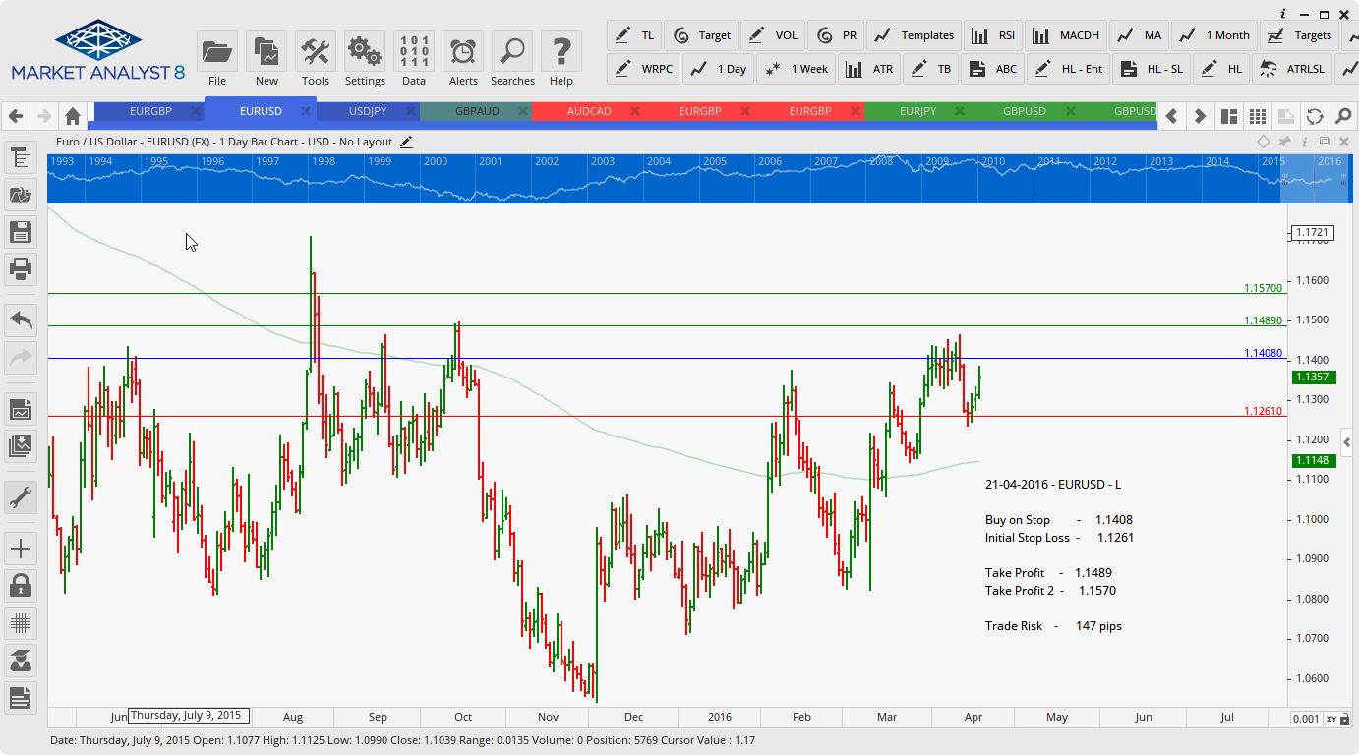

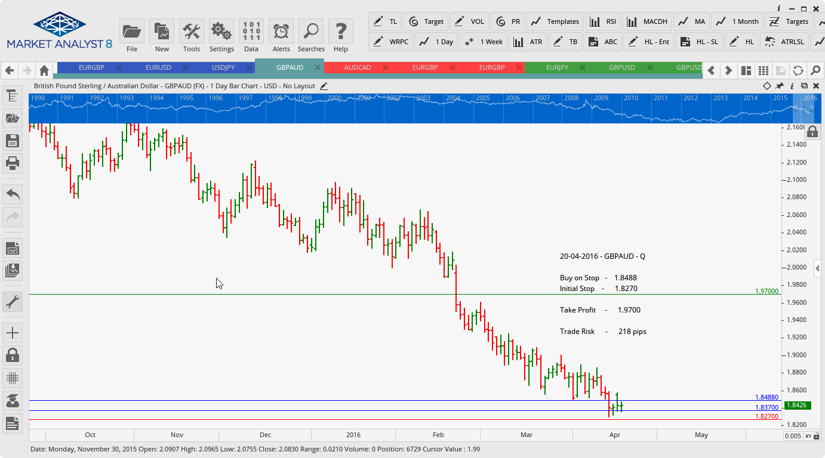

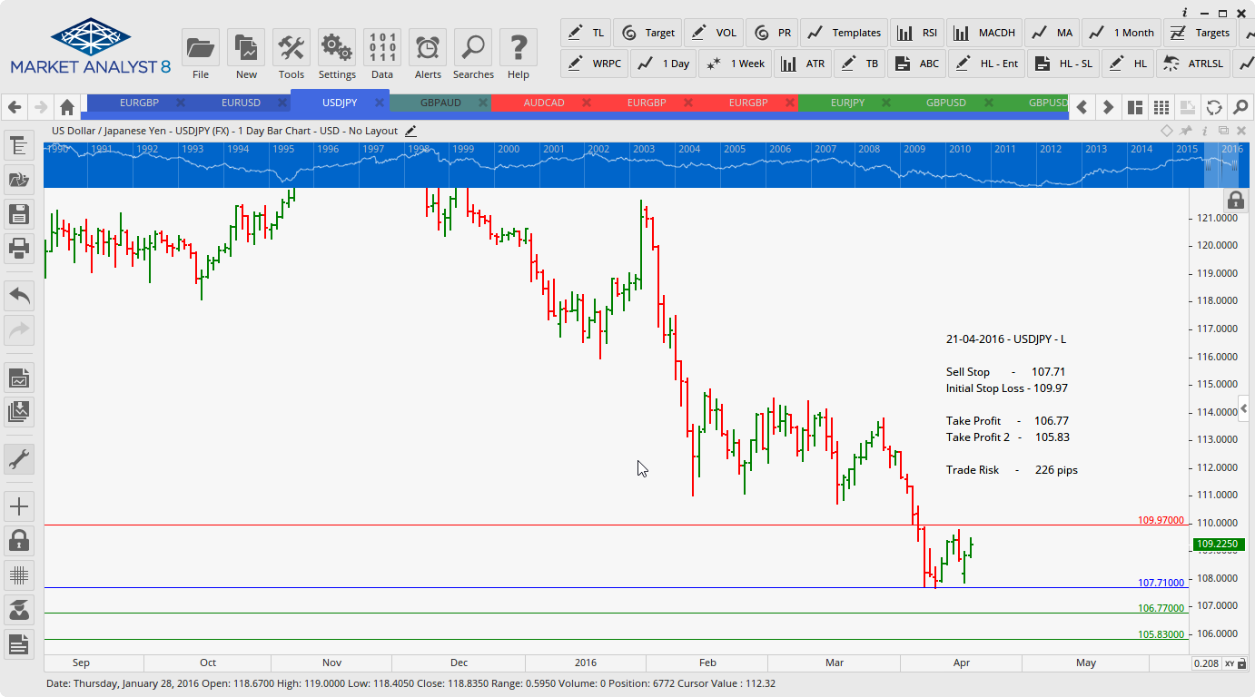

Limit Orders

